SPRINT-3

|  |  |
| --- | --- |
| TEAMID | PNT2022TMID47966 |
| ProjectName | IoTBasedsmartcropProtectionsystemforagriculture |
| Maximummark | 20marks |

STEP1:Simulatedprogramtogettherandomvalues.

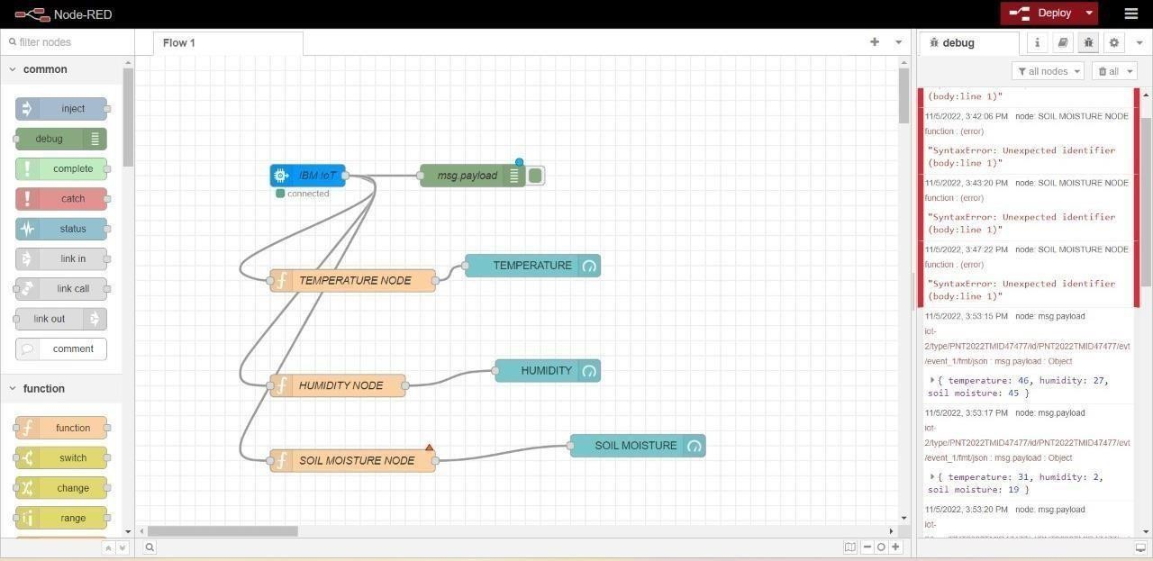

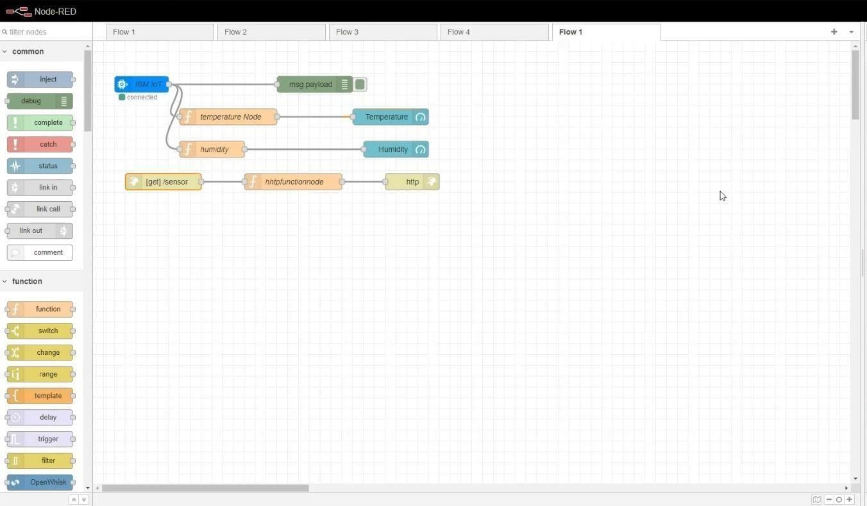

STEP2: Generate debug message from IBM Watson IoT Platform and connect the nodes.STEP3:Generatethe someoutput fromrecentevents.

